Experiment - 3

Aim:
To study and Implement Bare-metal Virtualization using Xen, HyperV or VMware Esxi.

Theory:
Type 1 or native hypervisors, sometimes referred to as bare-metal hypervisors, are virtualization systems that operate directly on a physical server's hardware without the use of a host operating system. By acting as a layer of abstraction between the virtual machines (VMs) and the hardware, they allow several operating systems to operate concurrently on a single physical server. The main advantage of bare-metal hypervisors over Type 2 hypervisors is their direct access to the underlying hardware resources, which leads to increased efficiency and performance.
Here are some key points about bare-metal hypervisors and their relevance in cloud computing platforms:
1. Performance Efficiency:
- Bare-metal hypervisors offer superior performance compared to Type 2 hypervisors because they operate directly on the hardware without the overhead of an additional operating system layer.
- This performance advantage is crucial in cloud computing environments where resource optimization and efficiency are paramount.
2. Resource Isolation:
- Bare-metal hypervisors provide strong isolation between virtual machines, ensuring that each VM has dedicated access to its allocated resources without interference from other VMs.
- This isolation is essential for maintaining security and stability in multi-tenant cloud environments, where multiple users or organizations share the same physical infrastructure.
3. Scalability:
- Bare-metal hypervisors contribute to the scalability of cloud platforms by allowing for the efficient utilization of physical server resources.
- The ability to run multiple VMs on a single server enables cloud providers to scale their infrastructure horizontally, adding more virtualized servers to meet increasing demand.
4. Resource Pooling:
- Cloud providers use bare-metal hypervisors to create resource pools, allowing them to dynamically allocate and reallocate computing resources based on demand.
- This resource pooling enables efficient utilization of resources and helps in achieving better overall performance and responsiveness.

5. Dedicated Workloads:
- Bare-metal hypervisors are well-suited for hosting performance-critical and resource-intensive workloads in the cloud, such as databases, big data processing, and high-performance computing applications.
- By providing direct access to hardware resources, bare-metal hypervisors minimize overhead and ensure that these workloads run with optimal performance.

6. Support for Specialized Hardware:
- Bare-metal hypervisors often support direct access to specialized hardware components, such as graphics processing units (GPUs) or hardware accelerators.
- This capability is crucial for applications that require specialized hardware resources, like machine learning and scientific simulations.In summary, bare-metal hypervisors play a significant role in cloud computing platforms by providing a foundation for efficient resource utilization, strong isolation, and scalability. Their direct access to hardware resources makes them particularly well-suited for hosting performance-critical workloads in cloud environments.

XenServer Architecture:
XenServer is an open-source virtualization platform based on the Xen Project. Its architecture is designed to provide efficient and secure virtualization capabilities for server environments. Here's a detailed overview of the XenServer architecture:
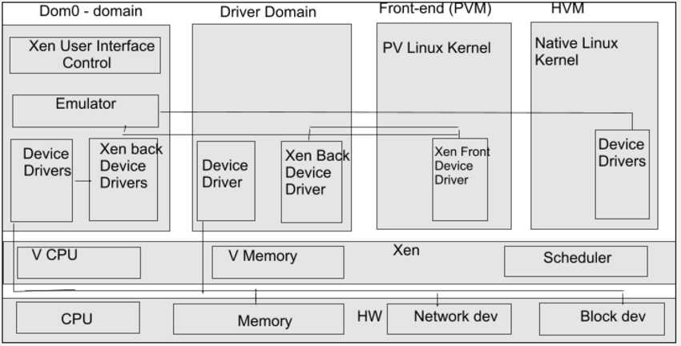

1. Xen Hypervisor:
- At the core of XenServer is the Xen hypervisor, a lightweight and efficient layer that runs directly on the hardware without the need for an underlying operating system. The hypervisor is responsible for managing and controlling access to the physical hardware resources.
2. Control Domain (Dom0):
- Dom0, or Domain 0, is a privileged virtual machine running a modified Linux distribution (usually a trimmed-down version of CentOS). It is responsible for controlling and managing the XenServer host.
- Dom0 has direct access to the physical hardware and runs the XenServer toolstack, which includes the XenAPI (Application Programming Interface) that enables communication between management interfaces and the Xen hypervisor.
- The toolstack allows administrators to perform various management tasks, such as creating, configuring, and monitoring virtual machines.

3. Guest Domains (DomU):
- DomU, or Domain U, represents unprivileged virtual machines running on the XenServer host. Each DomU runs its own guest operating system and applications.
- DomU instances are isolated from each other and from Dom0, ensuring security and preventing interference between virtual machines.
4. XenAPI:
- XenAPI is a set of APIs provided by XenServer that allows external applications and management tools to interact with the Xen hypervisor and control Dom0.
- It facilitates the automation of administrative tasks, making it easier to manage and monitor the virtualized environment.
5. Toolstack:
- The toolstack is a set of management utilities and services responsible for handling administrative tasks. It operates within Dom0 and communicates with the Xen hypervisor through the XenAPI.
- Common components of the toolstack include:
- Xenopsd: Manages the lifecycle of VMs, handling operations like start, stop, and migrate.
- Xapi: Provides a high-level interface for administrators to interact with the virtualization platform.

6. Hardware Virtualization Support:
- XenServer leverages hardware virtualization support in modern CPUs (Intel VT-x and AMD-V) to improve performance and enhance the efficiency of virtualization. This allows VMs to run more directly on the hardware, reducing overhead.
7. Storage Repositories:
- Storage repositories (SRs) are used to store virtual machine images, ISO files, and snapshots. Different types of SRs, such as local storage, NFS, or iSCSI, can be configured based on the specific needs of the virtualized environment.
8. Network Virtualization:
- XenServer provides network virtualization capabilities, allowing administrators to create and manage virtual networks for VM communication. This includes support for VLANs, virtual switches, and other network configurations.
9. XenCenter:
- XenCenter is a graphical management tool provided by Citrix for managing XenServer environments. It allows administrators to perform tasks such as creating and configuring VMs, monitoring performance, and handling virtualized storage and networking.
10. Resource Pools:
- XenServer supports the creation of resource pools, allowing administrators to group multiple hosts together and manage them as a single entity. This enables efficient resource utilization and load balancing across multiple physical servers.

XenServer Installation Steps:
Step 1: Boot from Installation Media
- Insert the XenServer installation media (DVD or USB) into the server.
- Boot the server from the installation media.
- Follow the on-screen prompts to initiate the installation process.
Step 2: Installation Options
- Choose the appropriate installation option (e.g., "Install XenServer").
- Accept the license agreement and proceed.
Step 3: Disk Configuration
- Select the destination disk for XenServer installation.
- Confirm the partitioning scheme or customize it as needed.
Step 4: Network Configuration
- Configure network settings, including IP address, subnet mask, gateway, and DNS.
- Confirm the settings and proceed with the installation.
Step 5: Installation Completion
- Set a strong password for the root user.
- Allow the installation to complete, and then remove the installation media.
- Reboot the server.

Creating a Storage Repository (SR):
Step 1: Access XenCenter
- Install XenCenter on a separate Windows machine.
- Launch XenCenter and click on "Add a Server" to connect to your XenServer host.
Step 2: Connect to XenServer
- Enter the XenServer host's IP address or hostname.
- Provide the root credentials when prompted.
- Click "Connect" to access XenServer.
Step 3: Create Storage Repository
- In XenCenter, navigate to the "Storage" tab.
- Click on the host server, and in the "Storage" tab, right-click and choose "New Storage."
- Follow the wizard to create a new Storage Repository (SR).
- Choose the storage type (e.g., LVM, NFS, or other supported types).
- Specify the location and settings for the new SR.

Installing a Virtual Machine (VM):
Step 1: Create VM
- In XenCenter, navigate to the "Home" tab.
- Click on the host server, and in the toolbar, click on "New VM."
Step 2: VM Installation Wizard
- Follow the VM creation wizard:
- Choose a name and description for the VM.
- Select the guest operating system type.
- Allocate memory, CPU, and other resources.
- Specify the storage location for the VM.
Step 3: Install Guest OS
- Attach the installation ISO for the guest OS to the VM.
- Start the VM and proceed with the guest OS installation.
Step 4: VM Configuration
- After the guest OS is installed, configure additional VM settings.
- Customize networking, storage, and any other parameters as needed.
Step 5: Start the VM
- Start the VM and verify that it is running successfully.

Connecting to XenServer Using XenCenter:
Step 1: Launch XenCenter
- Open XenCenter on the Windows machine.

Step 2: Connect to XenServer
- Click on "Connect to a server" in the XenCenter toolbar.
- Enter the XenServer host's IP address or hostname.
- Provide the root credentials when prompted.
- Click "Connect" to access XenServer.
Step 3: Manage XenServer
- Once connected, XenCenter will display a graphical interface for managing VMs, storage, and networking.
- Use XenCenter for ongoing management tasks, monitoring, and administration of the XenServer environment.

Output:
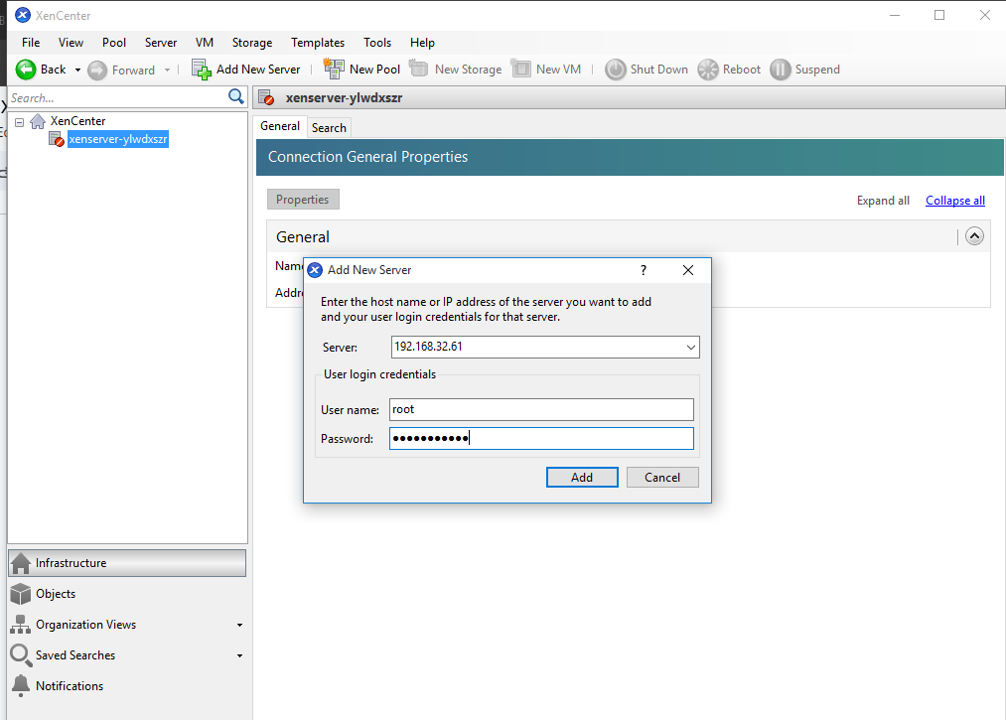

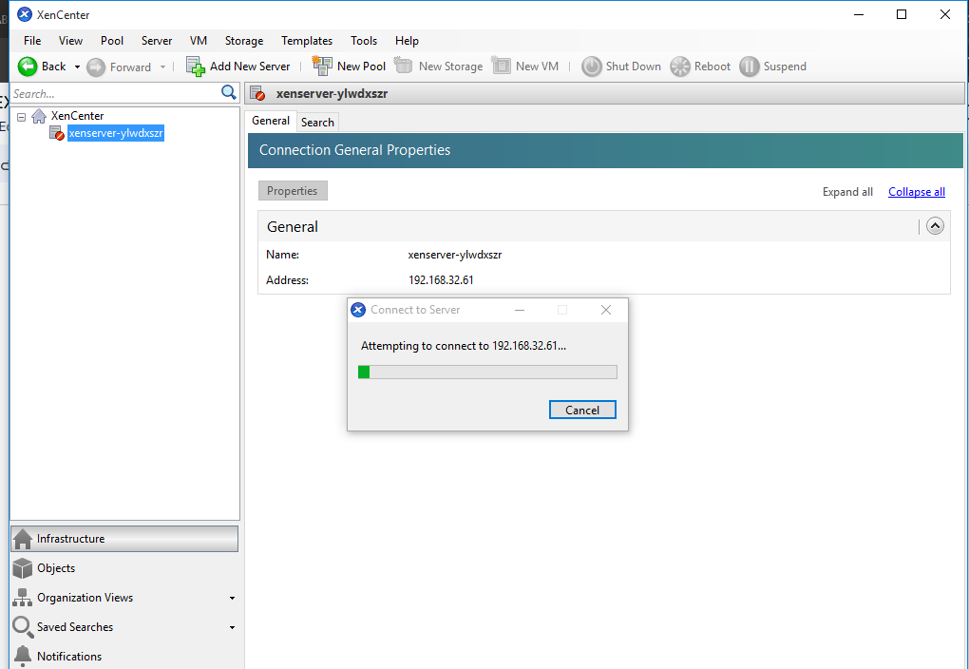
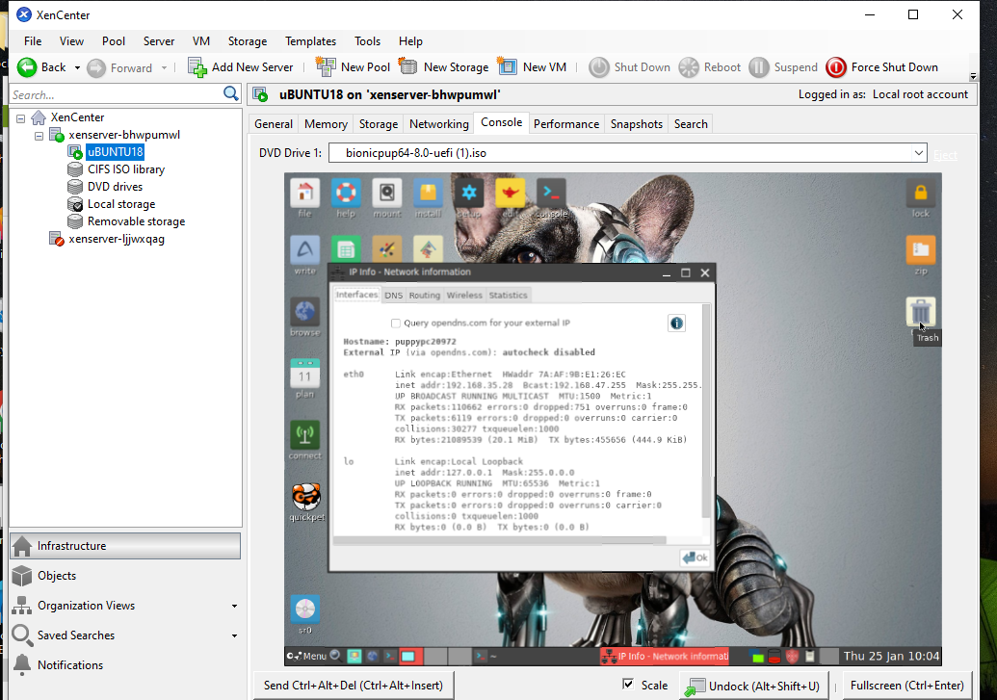

Conclusion:
In order to create a working virtualization environment, we carefully followed the instructions for installing XenServer, setting up a storage repository, and establishing a virtual machine in this extensive experiment. The efficiency and security characteristics of the XenServer architecture were highlighted as it revolved around the Xen hypervisor, Dom0, and the XenAPI. Following a successful installation, XenServer was deployed by configuring disk partitions, network settings, and root credentials additionally utilizing XenCenter to establish a connection with XenServer offered an easy-to-use interface for continuing management duties.

